Access to HP SM 9.20 through Tomcat 6.0
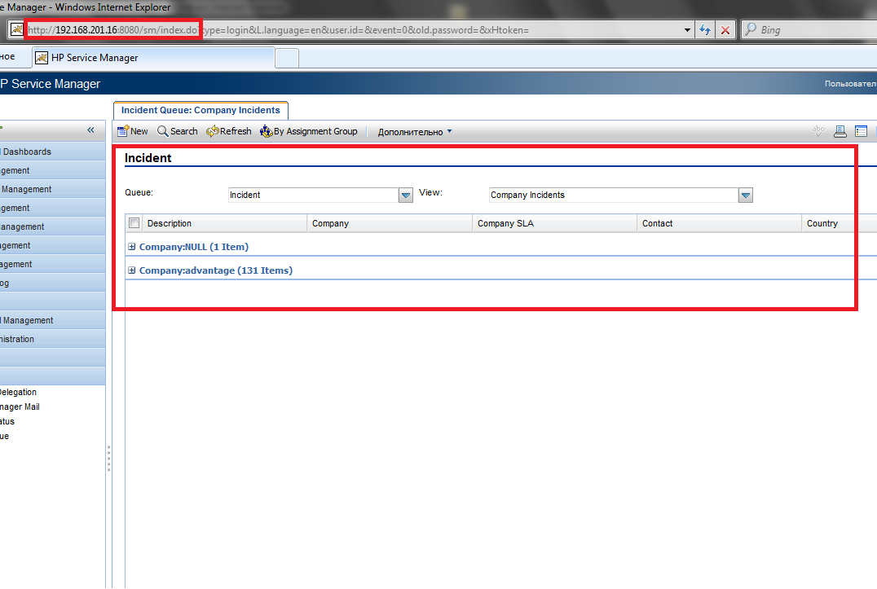
Access to HP SM 9.20 though Apache 2.2.16 HTTP web server
